PROJECT REPORT OF INDUSTRY ORIENTED HANDS ON EXPERIENCE (IOHE)
ON
Quizy – AI-Powered Quiz Generator
submitted in partial fulfilment of the requirements for the award of degree of

BACHELOR OF ENGINEERING
In
COMPUTER SCIENCE AND ENGINEERING
Submitted by: Supervised By:

Saurabh Malik (2210992269) Dr Preeti Saini
Shivam (2210992313) Assistant Professor
Shivam (2210992307)
Rohit (2210992177)


DEPARTMENT OF COMPUTER SCIENCE AND ENGINEERING
CHITKARA UNIVERSITY
CHANDIGARH-PATIALA NATIONAL HIGHWAY, RAJPURA, PUNJAB, INDIA
DECLARATION

I hereby certify that the work which is being presented in the project report entitled Quizy – AI powered Quiz Generator in partial fulfilment of requirement for the award of the degree of Bachelor of Engineering (Computer Science and Engineering) submitted in the department of Computer Science and Engineering at Chitkara University Institute of Engineering and Technology, Chitkara University, Punjab, India, is an authentic record of my own work carried out under the supervision of Dr Preeti Saini. The matter presented in this project report has not been submitted in any other university/institute for the award of any degree.

Saurabh Shivam Shivam Rohit
2210992269 2210992313 2210992307 2210992177
Place:Rajpura Date:07-05-2026

This is to certify that the above statement made by the candidate is correct to the best of my knowledge and belief.

Dr. Preeti Saini
Assistant Professor
Department of Computer Science and Engineering
Chitkara University Institute of Engineering and Technology,
Chitkara University, Punjab, India

ACKNOWLEDGEMENT

It is our pleasure to be indebted to various people, who directly or indirectly contributed to the development of this work and who influenced my thinking, behavior and acts during the course of study. We express our sincere gratitude to all for providing me an opportunity to undergo Integrated Project as the part of the curriculum.

We are thankful to Dr Preeti Saini for his support, cooperation, and motivation provided to us during the training for constant inspiration, presence and blessings.

Lastly, we would like to thank the almighty and our parents for their moral support and friends with whom we shared our day-to day experience and received lots of suggestions that improve our quality of work.

Saurabh Malik Shivam Shivam Rohit
2210992269 2210992313 2210992307 2210992177

Table of Contents

S. L. No. | Topics | Page No.
1. | Introduction | 5
2. | Background | 5
3 | Problem Statement | 5-6
4 | Software and Hardware Requirement Specification | 6
5. | System Architecture | 6-7
6. | Database Analyzing, Design and Implementation | 7-8
7 | Program’s Structure Analyzing and GUI Constructing | 9-11
8 | Code-Implementation and Database Connections | 12
9. | AI / ML Model Integration | 12
10 | Testing and Validation | 12
11 | Limitations | 13
12 | Conclusion | 13
13 | Future Scope | 14-15
14 | Bibliography/References | 15

1. Introduction to the Project
- Quizzy is an AI-generated quiz platform designed to automate the creation, delivery, and evaluation of quizzes using modern web technologies and artificial intelligence. The platform addresses the growing need for intelligent digital assessment systems in education, recruitment, and professional training. With the rapid shift toward online learning environments, traditional assessment systems often fail to provide adaptability, scalability, and meaningful feedback.

- Quizzy leverages artificial intelligence to dynamically generate quiz questions based on user-defined topics, difficulty levels, and question formats. This automation significantly reduces the manual effort required by educators while ensuring consistency and relevance of questions. The platform also provides real-time evaluation, performance analytics, and a visually intuitive user interface.

2. Background
- Online assessments have become a cornerstone of modern education systems. However, most existing quiz platforms rely on static question banks and provide limited analytics. Such systems fail to adapt to individual learning patterns and do not support intelligent assessment strategies.

- The emergence of Artificial Intelligence (AI), Natural Language Processing (NLP), and cloud computing has transformed the educational technology landscape. AI-driven platforms can now generate content, analyze learner behavior, and provide personalized feedback. Quizzy adopts these technologies to bridge the gap between traditional assessments and intelligent learning systems.

3. Problem Statement
- Despite the widespread availability of online quiz and assessment platforms, most existing systems continue to rely on static question banks and manual content creation processes. These platforms offer limited automation and lack the ability to dynamically generate questions based on user requirements such as topic relevance, difficulty level, and learning objectives. As a result, educators and trainers are required to invest significant time and effort in designing assessments, which often leads to repetitive, less engaging, and non-adaptive evaluation methods.
- Furthermore, current quiz platforms primarily focus on delivering numerical scores as the final outcome of an assessment. They fail to provide in-depth performance insights, conceptual clarity analysis, or personalized feedback that could help learners understand their strengths and areas for improvement. The absence of intelligent analytics limits the effectiveness of assessments as a learning tool rather than just an evaluation mechanism.
- Another major limitation of existing systems is the lack of personalization. Learners with varying knowledge levels are subjected to the same set of questions, ignoring individual learning patterns and pace. This one-size-fits-all approach reduces learner engagement and does not support adaptive learning methodologies. Additionally, scalability and data security remain critical concerns, as many platforms struggle to efficiently handle increasing user loads while ensuring the protection of sensitive user data.
- Therefore, there is a strong need for an intelligent, secure, and scalable quiz platform that can automate quiz creation using artificial intelligence, evaluate responses in real time, and generate meaningful analytical insights. The proposed system, Quizzy, aims to address these challenges by integrating AI-driven question generation, personalized assessment workflows, and detailed performance analytics within a modern web-based architecture. This platform seeks to transform traditional online assessments into an intelligent learning experience that benefits both educators and learners.

4. Software and Hardware Requirement Specification
4.1 Software Requirements
- Frontend: Next.js , Tailwind CSS
- Backend: Node.js, Express.js
- Database: NeonDB (PostgreSQL) and MongoDB
- Authentication: Firebase Authentication
- AI Integration: Gemini API
- Development Tools: VS Code, Git, Postman

4.2 Hardware Requirements
- Minimum 4 GB RAM
- Intel i3 or higher processor
- Stable internet connection
- Modern web browser

5. System Architecture
- Quizzy follows a robust client–server architecture that is tightly integrated with cloud-based artificial intelligence services to ensure high performance, scalability, and reliability. The system is designed using a modular approach, where each component operates independently while communicating seamlessly with other components through well-defined interfaces. This architectural design enhances maintainability, extensibility, and fault isolation.

- The frontend of the application is developed using Next.js, a modern React-based framework that enables server-side rendering and optimized client-side interactions. The frontend provides a responsive and user-friendly interface through which users can register, log in, create quizzes, attempt quizzes, and view performance summaries. All user interactions are processed through RESTful API calls, ensuring secure and structured communication with the backend services.

- The backend is implemented using Node.js and Express.js, which handle core application logic such as quiz creation, question generation requests, answer validation, score calculation, and analytics processing. Firebase Authentication is integrated to manage secure user authentication and authorization, ensuring that only authenticated users can access personalized features such as quiz history and performance data.

- Artificial intelligence functionality is incorporated through the Gemini API, which is responsible for generating intelligent, topic-specific quiz questions based on user input. The AI service analyzes the contextual relevance of the topic and produces well-structured questions with appropriate difficulty levels, significantly reducing manual content creation effort.

- For data management, the backend communicates with NeonDB, a cloud-based PostgreSQL database, to store structured and relational data such as user profiles, quiz metadata, questions, and responses. In addition, MongoDB is used to handle unstructured and semi-structured data, particularly for storing analytics, performance logs, and user activity patterns. This hybrid database approach ensures efficient data retrieval, flexibility, and scalability.

- Overall, the architecture of Quizzy is designed to support high concurrency, secure data handling, and seamless AI integration. By leveraging cloud services, modern web technologies, and intelligent automation, the system achieves scalability, modularity, and security while delivering a reliable and efficient quiz generation and evaluation platform.

6. Database Analyzing, Design and Implementation
- Quizzy adopts a hybrid database approach to efficiently manage various types of data generated within the platform, including user information, quiz details, questions, quiz attempts, and performance analytics. This approach combines the strengths of both relational and non-relational databases to ensure high performance, scalability, and data integrity. Structured and relational data such as user profiles, quiz metadata, questions, and responses are stored in a relational database, enabling efficient querying and consistency through well-defined schemas.
- Key entities in the database include User, Quiz, Question, Attempt, and Analytics. Each entity is uniquely identified using system-generated identifiers, which help maintain accurate relationships among users, quizzes, and attempts. The Attempt entity plays a crucial role in linking users to their quiz interactions, allowing the system to track performance across multiple attempts. Analytics data, including accuracy, time taken, and topic-wise performance, is stored separately to support detailed performance evaluation. This database design ensures reliable data management, fast retrieval, and seamless scalability as the number of users and quiz activities increases.

Data Flow Diagram Level 0

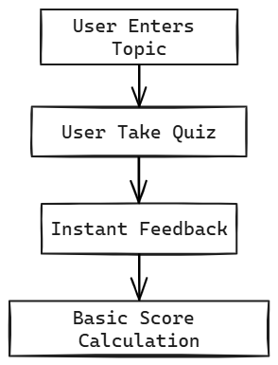
Data Flow Diagram Level 1

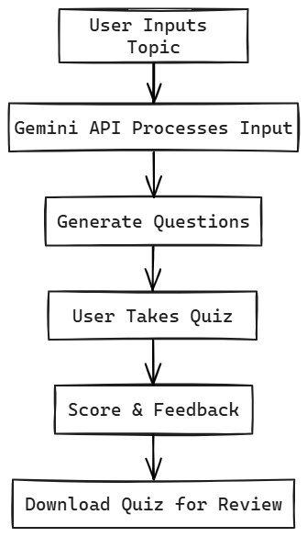

7. Program Structure and GUI Construction
- The frontend of Quizzy is designed with a modern dark-themed user interface that enhances visual comfort, improves readability, and reduces eye strain during extended usage. The consistent color scheme and layout help users remain focused while interacting with the platform.
- • The dashboard serves as the central control panel, providing users with quick and intuitive access to key features such as quiz creation, quiz history, hot topics, and recent activity. This organized layout ensures efficient navigation and improves overall user experience.
- • Quizzy enables users to create customized quizzes by simply entering a topic of interest, selecting the desired number of questions, and choosing the type of questions (multiple choice or open-ended), making the quiz creation process fast and user-friendly.
- • The interface is designed to ensure minimal user effort and smooth navigation, with clearly labeled buttons, responsive components, and logical workflows that reduce complexity even for first-time users.

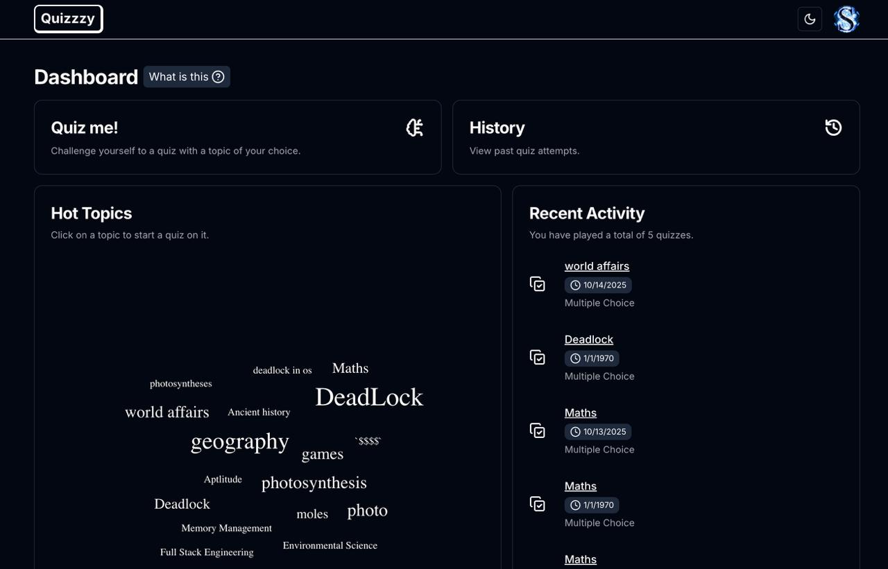

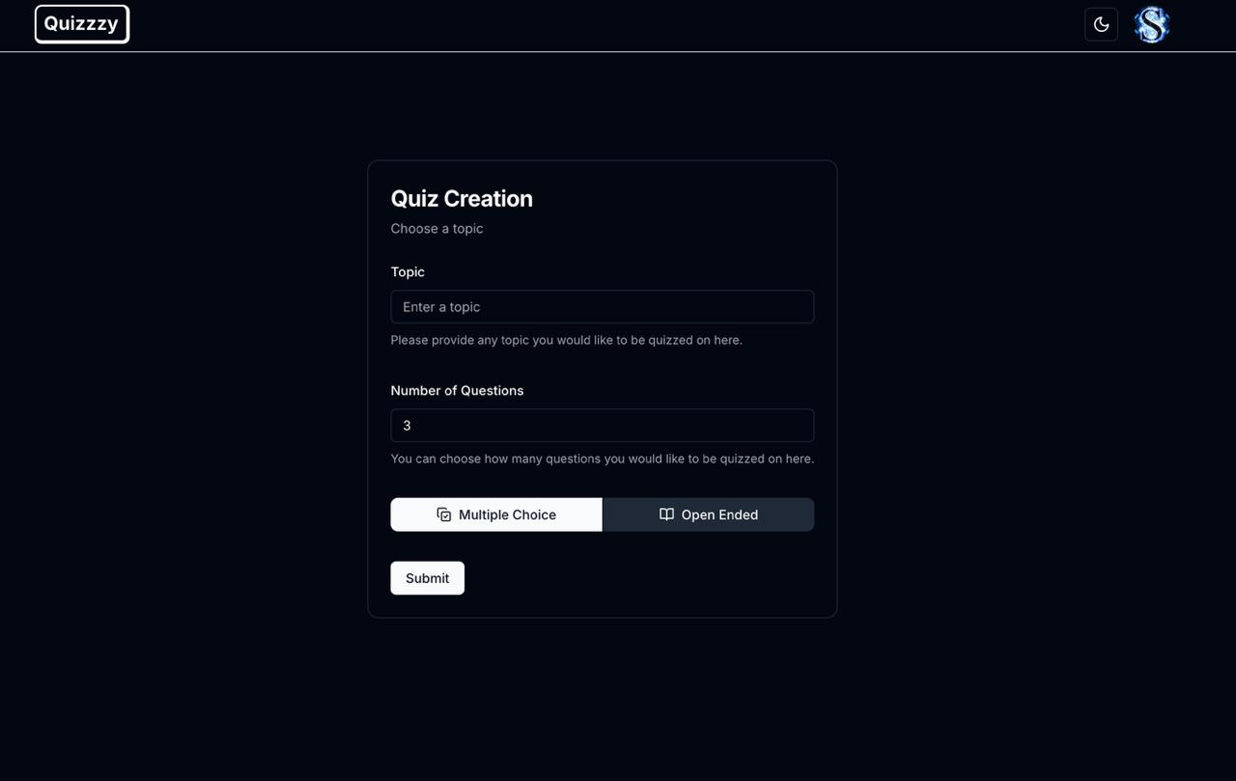

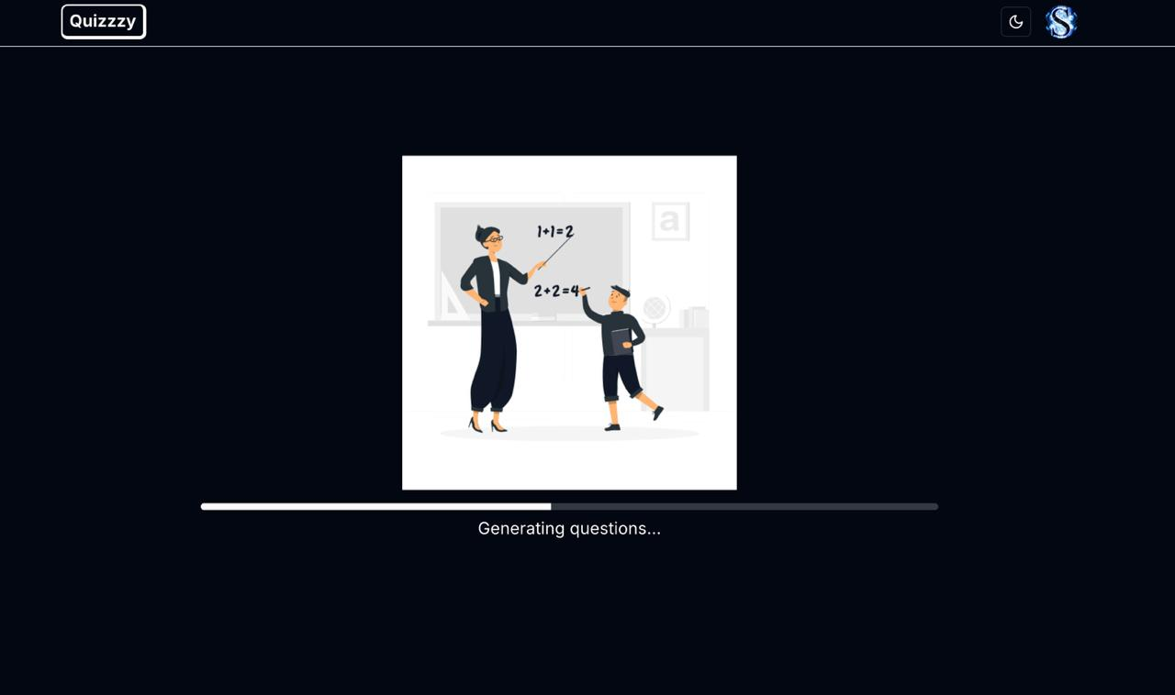
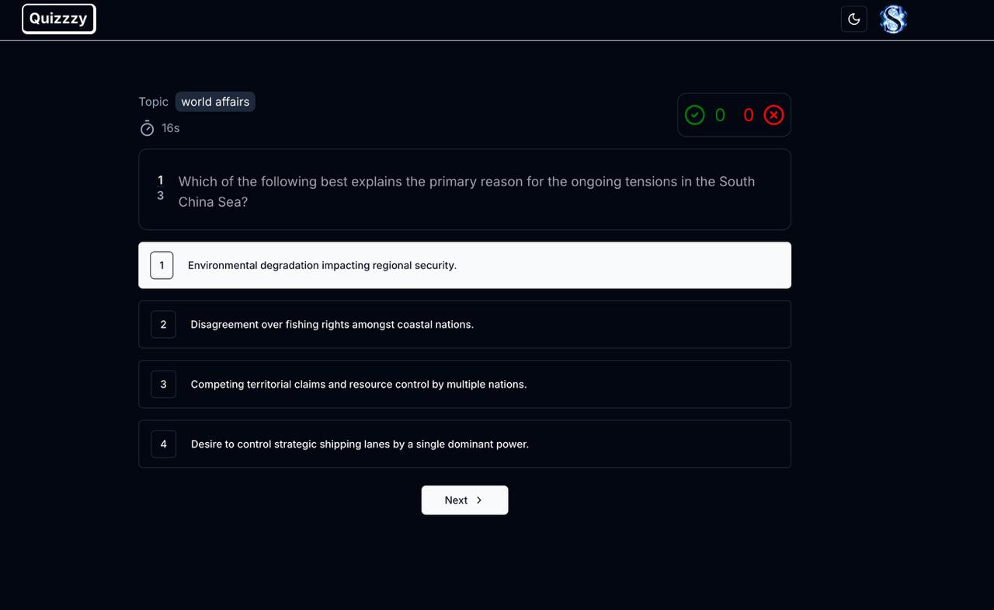

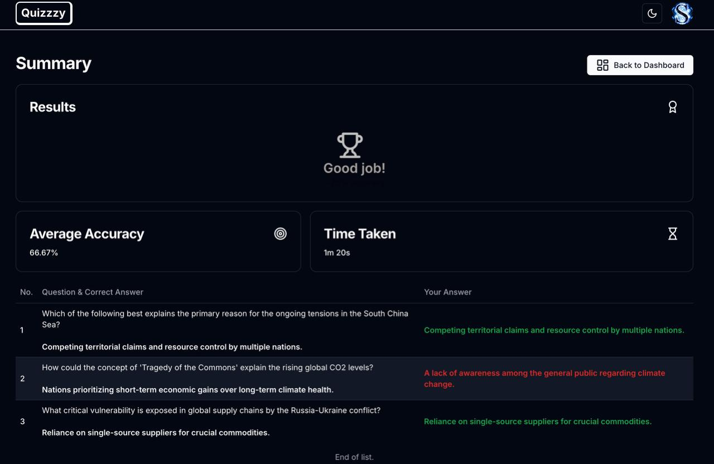

8. Code Implementation and Database Connectivity
- The backend of the Quizzy platform is implemented using Express.js, a lightweight and efficient Node.js framework that enables the development of scalable RESTful APIs. These APIs handle core functionalities such as quiz generation, quiz submission, answer evaluation, user management, and analytics processing. Each API endpoint is designed with proper request validation and error handling to ensure secure and reliable communication between the client and server.
- Secure user sessions are maintained using token-based authentication mechanisms, ensuring that only authorized users can access protected resources. On the frontend, asynchronous HTTP requests are used to interact with backend services, allowing data to be fetched and updated without interrupting the user experience. Efficient state management techniques are employed to ensure smooth rendering, real-time updates, and consistent synchronization between the user interface and backend data.

9. AI / ML Model Integration
- Quizzy integrates artificial intelligence capabilities through the Gemini API to automate the quiz generation process. The AI model uses Natural Language Processing (NLP) techniques to analyze the topic provided by the user and generate relevant, well-structured questions. The model considers contextual meaning, keyword relevance, and difficulty levels to ensure the quality and appropriateness of generated questions.
- In addition to question generation, the system analyzes user performance data such as accuracy, response time, and topic-wise results. This data-driven approach enables the platform to adapt future quizzes based on user strengths and weaknesses. Over time, the AI system continuously improves its recommendations, supporting adaptive assessments and personalized learning experiences.

10. Testing and Validation
- To ensure system reliability and performance, Quizzy undergoes multiple levels of testing throughout the development lifecycle. Unit testing is conducted to verify the correctness of individual components such as API endpoints and utility functions. Integration testing ensures smooth interaction between the frontend, backend, database, and AI services.
- API endpoints are tested using Postman to validate request handling, response accuracy, and error management. Additionally, user acceptance testing (UAT) is performed to evaluate usability, responsiveness, and overall user experience across different devices and screen sizes. These testing practices help identify bugs early and ensure a stable and user-friendly platform.

11. Limitations
• The platform is highly dependent on stable internet connectivity, which may affect usability in low-network environments.
• The accuracy and quality of AI-generated content depend on prompt clarity and AI model limitations.
• Handling high traffic loads requires additional cloud optimization and infrastructure scaling.
• Offline functionality is currently limited, restricting access to quizzes without an active connection.

12. Conclusion
- Quizzy successfully demonstrates the effective application of artificial intelligence and modern web technologies in the domain of digital assessments. By automating the processes of quiz generation, response evaluation, and performance analysis, the platform significantly reduces the manual effort traditionally required by educators and administrators. The use of AI-driven question generation ensures that assessments remain relevant, consistent, and adaptable to different topics and difficulty levels, thereby enhancing the overall quality of evaluations.
- In addition to automation, Quizzy provides meaningful analytical insights that go beyond simple numerical scores. Learners are able to understand their performance patterns, strengths, and areas requiring improvement through structured feedback and analytics. The integration of a modern, responsive user interface further improves accessibility and user engagement, making the platform suitable for both academic and professional use cases.
- Overall, Quizzy stands as a scalable, secure, and intelligent assessment platform that bridges the gap between traditional quiz systems and next-generation adaptive learning solutions. With continuous improvements in AI integration and system optimization, Quizzy has strong potential to evolve into a comprehensive digital evaluation ecosystem capable of supporting large-scale educational and organizational assessment needs.

13. Future Scope
- The Quizzy platform offers significant potential for future enhancements as advancements in artificial intelligence, cloud computing, and educational technologies continue to evolve. One of the primary areas of expansion is the implementation of adaptive learning paths, where the system dynamically adjusts quiz difficulty, question types, and topics based on individual user performance. Such personalization can transform Quizzy from a simple assessment tool into a comprehensive learning companion that supports continuous improvement.
- Another major enhancement involves the introduction of multilingual support, enabling quiz generation and evaluation in multiple regional and international languages. This feature would make the platform accessible to a broader and more diverse user base, particularly in multilingual academic environments and global organizations. AI-powered language translation and localization techniques can further improve content accuracy and cultural relevance.
- Quizzy can also be enhanced through the integration of gamification elements such as leaderboards, badges, achievement levels, and reward systems. These features would increase learner motivation, encourage healthy competition, and improve user engagement. Gamification has been shown to significantly enhance participation and retention in online learning platforms.
- Integration with Learning Management Systems (LMS) such as Moodle, Google Classroom, and enterprise training platforms represents another important future direction. LMS integration would allow seamless data exchange, enabling educators to manage quizzes, track progress, and generate reports within a unified educational ecosystem. This would make Quizzy suitable for institutional-level deployment.
- From a technological perspective, the platform can incorporate voice-based and conversational quiz interfaces, enabling users to interact with quizzes using speech recognition and voice commands. This enhancement would improve accessibility for users with visual impairments and support hands-free learning experiences. Additionally, mobile application development can further extend platform reach by enabling offline quiz attempts and push notification-based reminders.
- Advanced analytics dashboards powered by machine learning can provide deeper insights into learner behavior, topic-wise mastery, and long-term performance trends. Predictive analytics can help identify at-risk learners and recommend corrective learning strategies. Furthermore, cloud optimization and microservices architecture can be adopted to support large-scale deployments, ensuring high availability, fault tolerance, and enhanced security.
- In conclusion, the future scope of Quizzy extends far beyond its current implementation. With continuous innovation, AI advancements, and system scalability improvements, Quizzy has the potential to evolve into a fully intelligent, adaptive, and globally accessible digital assessment and learning platform.

14. Bibliography / References

- React Documentation. (2025). React – A JavaScript library for building user interfaces. Retrieved from https://reactjs.org/docs/getting-started.html
- MongoDB Documentation. (2025). MongoDB – The developer data platform. Retrieved from https://www.mongodb.com/docs/
- Express.js Documentation. (2025). Express – Fast, unopinionated, minimalist web framework for Node.js. Retrieved from https://expressjs.com/
- Socket.IO Documentation. (2025). Socket.IO – Realtime WebSocket for Node.js. Retrieved from https://socket.io/docs/
- Node.js Documentation. (2025). Node.js – JavaScript runtime built on Chrome's V8 JavaScript engine. Retrieved from https://nodejs.org/en/docs/
- Mongoose Documentation. (2025). Mongoose – MongoDB object modeling for Node.js. Retrieved from https://mongoosejs.com/docs/
- JWT.io. (2025). JWT (JSON Web Tokens) Introduction. Retrieved from https://jwt.io/introduction/
- AWS Documentation. (2025). Amazon Web Services – Cloud computing platform. Retrieved from https://docs.aws.amazon.com/
- Botpress Documentation. (2025). Botpress – Open-source conversational AI platform. Retrieved from https://botpress.com/docs/
- Dotenv Documentation. (2025). dotenv – Load environment variables from a .env file. Retrieved from https://www.npmjs.com/package/dotenv
- bcrypt Documentation. (2025). bcrypt – Library to help hash passwords. Retrieved from https://www.npmjs.com/package/bcrypt
- Redux Toolkit Documentation. (2025). Redux Toolkit – The official, opinionated, batteries-included toolset for efficient Redux development. Retrieved from https://redux-toolkit.js.org/
- Tailwind CSS Documentation. (2025). Tailwind CSS – A utility-first CSS framework. Retrieved from https://tailwindcss.com/docs
- React Router Documentation. (2025). React Router – Declarative routing for React. Retrieved from https://reactrouter.com/en/main
- Chart.js Documentation. (2025). Chart.js – Simple yet flexible JavaScript charting library. Retrieved from https://www.chartjs.org/docs/latest/
- OpenAI API Documentation. (2025). OpenAI – API for natural language understanding and generation. Retrieved from https://platform.openai.com/docs
- Cloudinary Documentation. (2025). Cloudinary – Image and video management in the cloud. Retrieved from https://cloudinary.com/documentation

